THE RECIPE FOR LIFE IN A TYPICAL MALTESE VILLAGE
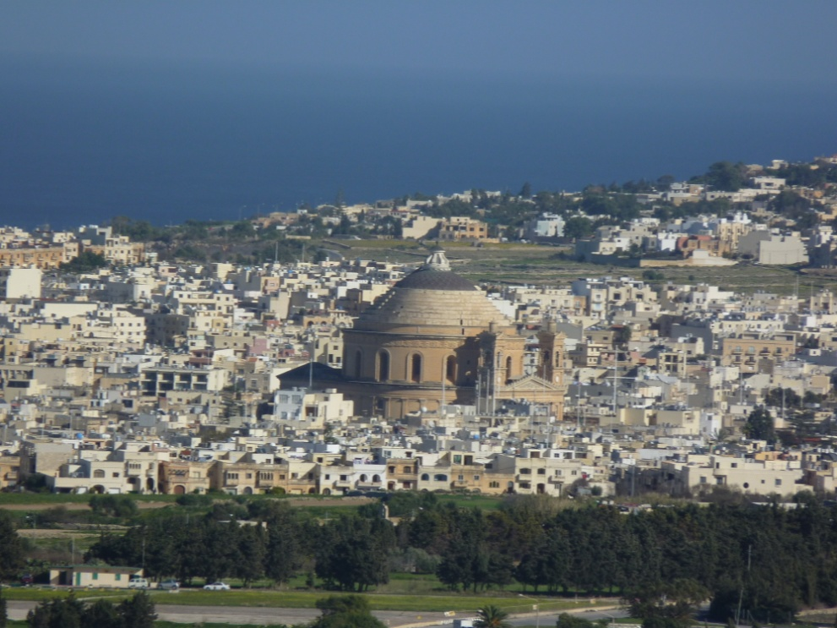

Malta being a nation of devout Catholics, at the very centre of every village is a church. The very culture of the Maltese revolves around this one magnificent building; old men meet there to chat and while away hours with pipe in mouth, whilst during the weekend the church is filled with people attending mass.
The church is what defines the Maltese village; as the structure looms over surrounding buildings, demanding a sense of awe and respect. At night, it is like a beacon in the darkness, glowing with a veritable multitude of lights and decorations, at the very centre of the spiritual and physical world the Maltese know so well. It is deeply embedded in their way of life, most particularly people over the age of 60, as they get up early, walk to church, listen to mass and then proceed to meet up with their friends and have a coffee in the village square. The church has an integral role in Malta; without it, the Maltese would lose a great part of their identity.
Educators and parents must point out, discuss and expose their children to the local village core. First hand observation and hands-on exposure is the best way to give students the foundation that they need for learning. For example, when parents are riding in the car with their children, they should talk to them about the area in which they are riding.

Name: Luke Scicluna
Form: 4
School: Archbishop’s Seminary School, Tal-Virtu, Rabat.Malta

