The Gateway to the Future of the Natural World… OUR world.
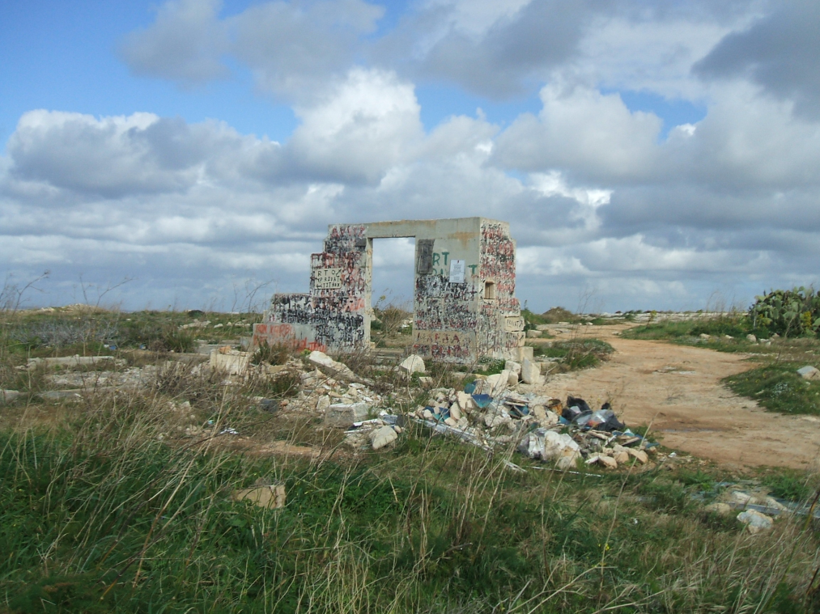

The opinion of most people living in the Maltese Islands today is that the environment is their rubbish tip. Around this structure, you can see a not-so-attractive assortment of rubble, plastic appliances, pipes, and wires, directly underneath a sign that says “Keep everywhere clean”. Is this some sort of sick joke? If this is what we have reduced ourselves to, what will we do next? How about burning down Buskett (Malta’s only woodland) and turning it into a landfill? Or maybe killing off every single bird that flies our way? The state of the Maltese countryside is a disgrace; and the people are doing nothing about it. The future looms ahead – will we avert course, or will we perish?
But what can we do? Is this acceptable? I could not resist of not going again to this site and not taking more photos. It changed... more rude words and vandalism on site! Is this what we are presenting in the year 2010? We discuss about new environmental programme, about new ideologies to improve environment, but what is being implemented? We need to start tackling every single issue. A lot of environmental projects are being held in schools, and hopefully these will help to change mentality and help students for a better world and active citizens.

Name: Luke Scicluna
Form 4

