Name: Fabio Cauchi
Form 4
School: Archbishop’s Seminary School, Tal-Virtu. Rabat, Malta
Shooting upon safety!
The Maltese islands are considered a gem of a city with the Mediterranean Sea surrounding it! Tourists visit Malta especially for its beaches. Thus safety signs are placed near these beaches. But are these signs being observed and noticed?
Unfortunately, in this photo we can see direct reactions of hunters for these protests and policies. One cannot judge that all hunters are doing this, but it is a pity that there are some irritated hunters that they will protest with vandalism. Over hunting in Malta has become a problem in the last few years.
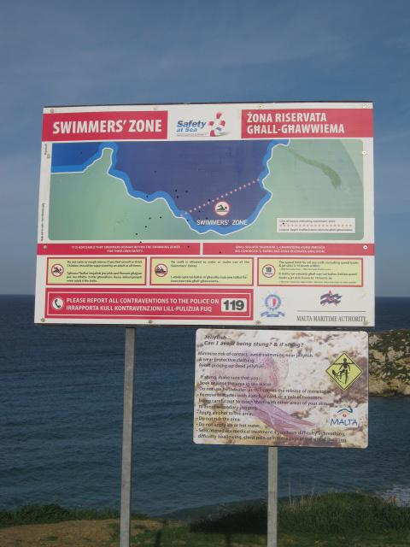
Such behavior towards the environment will lead to no good. Also these acts of vandalism will shadow our reputation with tourists. The only way to get out of this situation is to widen our mentality and be ready to work towards a better local environment. We need to invest in our environmental education programs and it is important that this will be an ongoing project in our schools.
