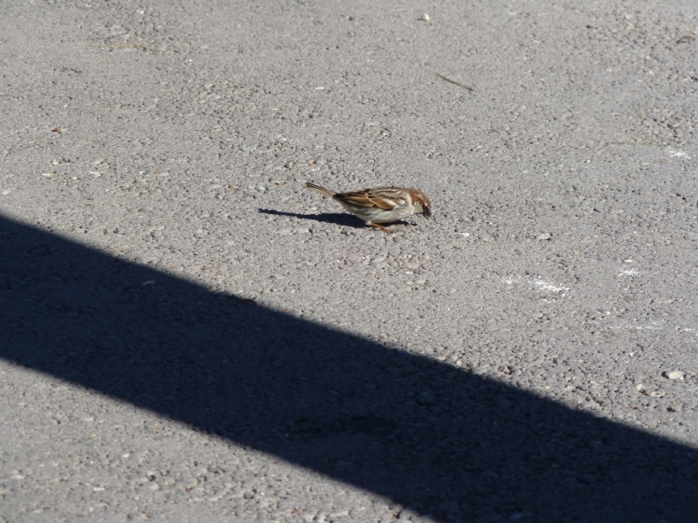

Stranded on a stretch of tarmac, this bird has been isolated in a world where it does not fit; wealth is all in modern life, and people do whatever they deem necessary to obtain said wealth, including covering vast swathes of land with dull tarmac, and building high-rise buildings on top of good land. Birds such as this one are deprived of their habitat, and end up living in ventilators and on roofs. It is a great pity that society does not consider creatures other than the human race when granting planning permission, building over green zones and pulling down trees.
Climate change is another major problem. This will pose an increasing threat to biodiversity in the coming decades. Plants and animals attempting to migrate with the changing conditions may find themselves in human territory with nowhere to go. Humanity is damning itself; the world is being ravaged for every last possible cent, and the apathy of the world’s leaders is showing through. Are we going to damn ourselves? First it’s a bird, and then it is an entire forest full of wildlife, until finally the world is a grey patch swept under a rug.
I conclude that awareness is always important point BUT a self conscious feeling has to be present in every human being, being it a child or a grand mum. We have to make the difference before it is too late. I had the opportunity to take this photo and see the bird, but in a couple of year’s time, would it possible to see him again? It is up to us!

Name: Luke Scicluna
Form 4

