SCHOOL ECO CODE:
ONE WORLD…
ONE DREAM…
ENVIRONMENT CLEAN!

Dear Mayor,

This scholastic year, our school the Archbishop’s Seminary is participating in the environmental project ‘Ekoskola’. In less than five months we have done a lot of activities and worked on environmental awareness and we would like that as the leader of our local council you will be informed about our work.

Please find attached our action plan for this year. This action plan was discussed during the ‘eko’ meetings and the team has done audits around the school to identify any work the team can do during this year. Visits from our ekoskola coordinator, Ms.Audrey Gauci, helped us to identify and work on our tasks.

Activities:

An eko-member is sending a weekly literature source to all students using emails. This will help to reduce paper, as well as educate students regarding the environment

During sunny days we proposed to do the lights out activities. We switch off all for the first two hours and a half; the positive thing is that most of the teachers continued turning the lights off without being told, so it was a great success.

During the month of November, the school presented a thematic week with the theme of environmental awareness. One week was spent on this theme, and related topics such as recycling, appreciating our environment, waste and climate changes were discussed through different subjects. During this week, we dedicated one day for workshops. The school invited experts from different local NGO’s and they came to discuss different matters with students as well as parents. Afterwards, we dedicated an afternoon, for a walk from our school to buskett and back. During our walk, we appreciated what our teachers explained about the Virtu Chapel, rubble walls, Verdala Palace and the flora and fauna of Buskett. This too was a successful event as well!

Recycling Bins have also been introduced into our classes. We had one for plastic another for paper. This encouraged the students to be more aware of recycling as well as responsible. It has been a success, that now we are going to invest in a good quality bins for our classrooms. We are going to start working on recycling bottles caps and sending them to a company which they turn exchange for wheelchairs.

The Compost Bin started off this week. During the environmental studies lessons, all classes are having a lesson about using the compost bin, and during the free time, some students have been doing a clean up to get dry leaves for the compost in the bin to be balanced.

Lunch Boxes – Encouragement was given from the beginning of the school term in forms 1 and 2, for all students to bring their lunch in a lunch box instead of using the compost bin. Nearly everyone is doing so.

Plants in our classrooms – In the junior classes, the students are being encouraged to bring plants for their classroom. The aim is to help them be responsible, and aware of having plants around us.

This week, we were invited to help another school participating in the ekoskola project. During the orientation visit they had in our school we presented our school action plan, discussed how we work together and encouraged them with our support.
We are currently on full swing discussing fun day and other relevant activities that have to do with the environment.

Thanks for your attention and we look forward to meeting you someday in our school so that we can show you our work, discuss our ideas and maybe plan an activity together.

Best Regards,
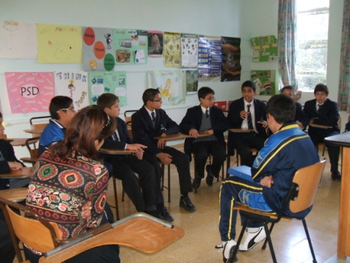
Andrew Abela
Ekoskola member

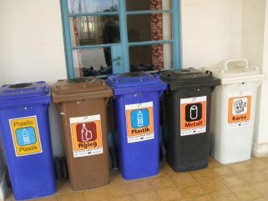
Figure 1 Recycling Bins

Figure 2 Ekoskola meetings

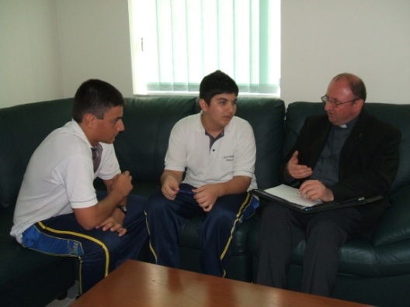
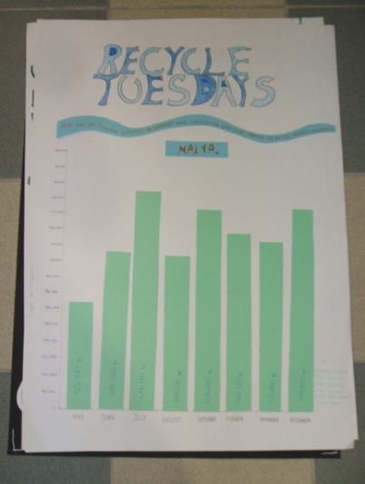
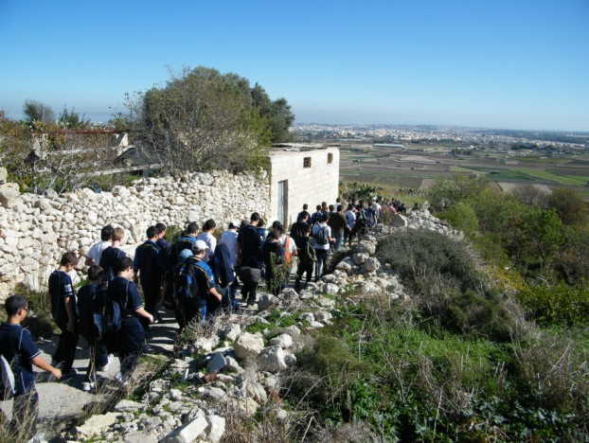
Figure 5 meeting with the Head of School to discuss school audits for ekoskola
Figure 3 Environmental awareness across the curriculum
Figure 4 Environmental Walk during the thematic week

